Week 7 - Integration Test V2

Project: Design an Autonomous Robot

Task: To design an autonomous robot that is capable of navigating to a predetermined position while avoiding obstacles and firing objects at two targets. This is to be done in the shortest time possible.

Document Version Number: 1.0

Hardware Version Number: 5.0

Software Version Number: 5.0

Date: April 8th, 2015

Author: James Fuh, Eric Vuong

Table of Contents

Purpose 2

Objective 2

Procedure 3

Format of Output 3

Conclusions 4

Distribution 4

## Purpose

The purpose of this report is to check the overall performance of the robot. On the competition day, the total time as well as the accuracy is important. The robot needs to travel in the shortest amount of time possible while hitting the targets on the way. As a result, it is important to make sure that the running time is not too long to complete all the actions.

## Objective

The objective of this test is to make sure that the robot can complete the tasks in a reasonable amount of time with accuracy. In the best-case scenario, the robot will be able to travel through the course without hitting any obstacles while hitting all the targets. In the worst-case scenario, the robot will either collapse on the blocks, or miss the shooting targets.

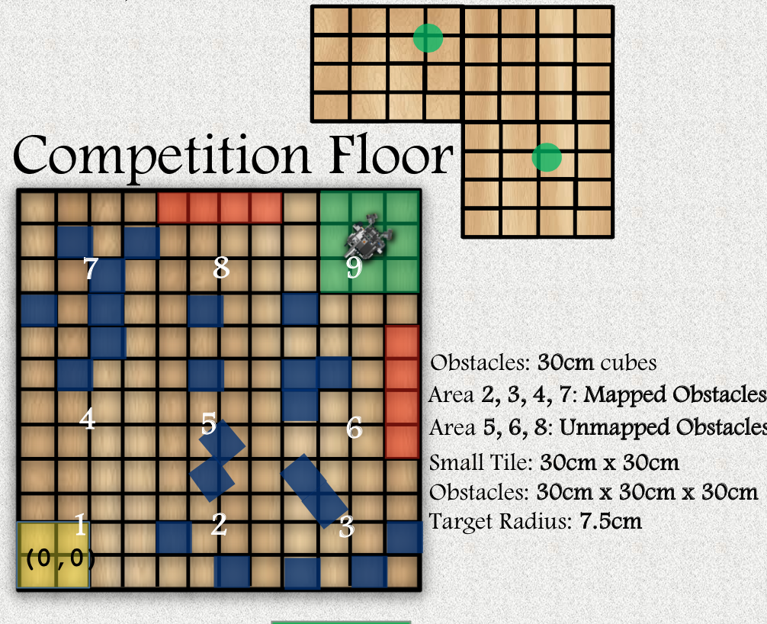

## Procedure

The Robot in white circle will travel through the course, which is bounded in a 12 by 12 dimension. After it travels to the green area spot, it will then shoot 3 balls to hit the target in the orange zone. As the robot is running, we will record the time and the outcome in each phase: localization phase (starting area and at shooting area), avoidance phase, and shooting phase. We will repeat this procedure 8 times to verify the consistency.

## Format of Output

|  |  |  |  |  |
| --- | --- | --- | --- | --- |
| Run | Localization | Avoidance | Shooting | Total Time |
| 1 | Pass, 1:02 | Pass, 0:27 | 2/3, 0:23 | 1:52 |
| 2 | Pass, 0:57 | Pass, 0:25 | 3/3, 0:30 | 1:52 |
| 3 | Pass, 0:55 | Pass, 0:31 | 3/3, 0:32 | 1:59 |
| 4 | Pass, 0:56 | Pass, 0:24 | 3/3, 0:27 | 1:47 |
| 5 | Pass, 0:50 | Pass, 0:26 | 2/3, 0:30 | 1:46 |
| 6 | Pass, 1:00 | Pass, 0:28 | 3/3, 0:24 | 1:52 |
| 7 | Pass, 0:52 | Pass, 0:29 | 2/3, 0:30 | 1:52 |
| 8 | Pass, 0:53 | Pass, 0:33 | 3/3, 0:29 | 1:55 |

## Conclusions

This simulation test is considered “passed”. The total time has improved significantly due to the increase of running speed in the localization mode. Furthermore, with the upgrade on the launcher, the accuracy of the robot has improved. The ball hits the target with 3 out of 3 more consistently, as shown in the data. Competition run time is 7 minutes maximum; the robot was able to perform 2/3 of the tasks asked in less than 2minutes. Thus, the robot can perform the tasks in a very short amount of time.

## Distribution

This test belongs to the hardware development and the software development.